**NATURAL LANGUAGE PROCESSING**

**TASK 2 COCA : CONCORDANCE SEARCH :**

GOOD MORNING:

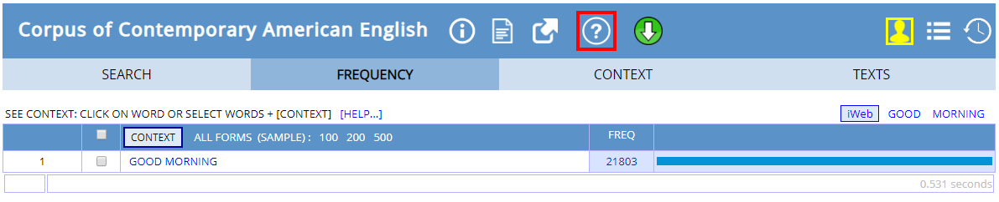

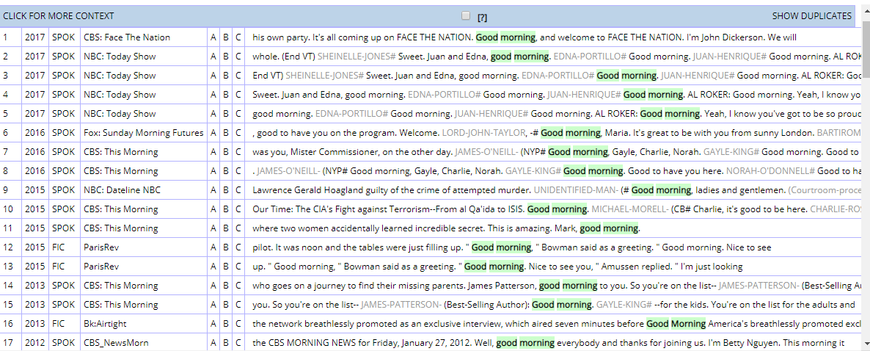

HELLO :

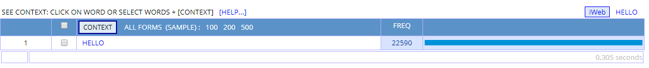

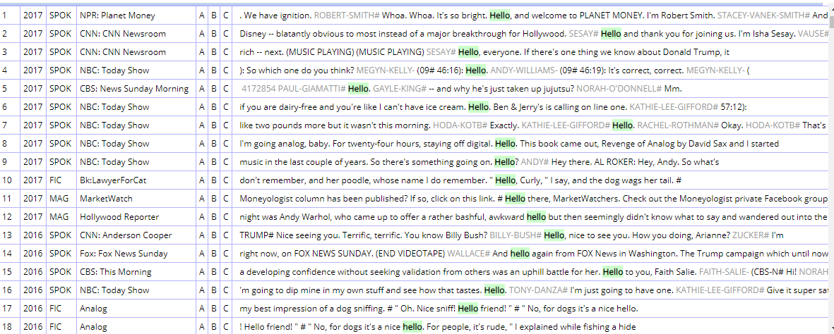

DONALD TRUMP:

